**CHATPER- 5**

**IMPLEMENTATION**

**5.IMPLEMENTATION**

Java Technology

Java technology is both a programming language and a platform.

**The Java Programming Language:**

**The Java programming language is a high-level language that can be characterized by all of the following buzzwords:**

* + - Simple
    - Architecture neutral
    - Object oriented
    - Portable
    - Distributed
    - High performance
    - Interpreted
    - Multithreaded
    - Robust
    - Dynamic
    - Secure

With most programming languages, you either compile or interpret a program so that you can run it on your computer. The Java programming language is unusual in that a program is both compiled and interpreted. With the compiler, first you translate a program into an intermediate language called *Java byte codes* —the platform-independent codes interpreted by the interpreter on the Java platform. The interpreter parses and runs each Java byte code instruction on the computer. Compilation happens just once; interpretation occurs each time the program is executed. The following figure illustrates how this works.

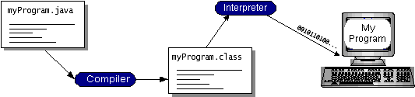

**Fig 5.1: Working of Java Program**

If we think of Java byte codes as the machine code instructions for the *Java Virtual Machine* (Java VM). Every Java interpreter, whether it’s a development tool or a Web browser that can run applets, is an implementation of the Java VM. Java byte codes help make “write once, run anywhere” possible. You can compile your program into byte codes on any platform that has a Java compiler. The byte codes can then be run on any implementation of the Java VM. That means that as long as a computer has a Java VM, the same program written in the Java programming language can run on Windows 2000, a Solaris workstation, or on an iMac.

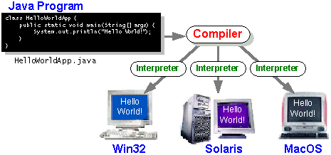

**Fig 5.2: Implementation of Java Virtual Machine**

The Java Platform

A *platform* is the hardware or software environment in which a program runs. We’ve already mentioned some of the most popular platforms like Windows 2000, Linux, Solaris, and MacOS. Most platforms can be described as a combination of the operating system and hardware. The Java platform differs from most other platforms in that it’s a software-only platform that runs on top of other hardware-based platforms.

The Java platform has two components:

* The *Java Virtual Machine* (Java VM)
* The *Java Application Programming Interface* (Java API)

You’ve already been introduced to the Java VM. It’s the base for the Java platform and is ported onto various hardware-based platforms.

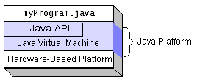

**Fig 5.3: Program Running on the Java Platform**

Native code is code that after you compile it, the compiled code runs on a specific hardware platform. As a platform-independent environment, the Java platform can be a bit slower than native code. However, smart compilers, well-tuned interpreters, and just-in-time byte code compilers can bring performance close to that of native code without threatening portability.

Feasibility Study

Technical Feasibility

GUI is developed using HTML to capture the information from the customer. HTML is used to display the content on the browser. It uses TCP/IP protocol. It is an interpreted language. It is very easy to develop a page/document using HTML some RAD (Rapid Application Development) tools are provided to quickly design/develop our application. So many objects such as button, text fields, and text area etc are provided to capture the information from the customer.

**Economical Feasibility**

The economical issues usually arise during the economical feasibility stage are whether the system will be used if it is developed and implemented, whether the financial benefits are equal are exceeds the costs. The cost for developing the project will include cost conducts full system investigation, cost of hardware and software for the class of being considered, the benefits in the form of reduced costs or fewer costly errors. The project is economically feasible if it is developed and installed. It reduces the work load. Keep the class of application in the view, the cost of hardware and software is considered to be economically feasible.

**Operational Feasibility**

In our application front end is developed using GUI. So it is very easy to the customer to enter the necessary information. But customer must have some knowledge on using

web applications before going to use our application.

**Step1: Installation of java:**

* Go to [http://www.oracle.com/technetwork/java/javase/downloads /index.html](http://www.oracle.com/technetwork/java/javase/downloads%20/index.html).
* click on JDK DOWNLOAD button. run the exe file and then follow the instruction given in wizard.
* **To set up the path**:-
  + Right click on my pc and then go to my properties

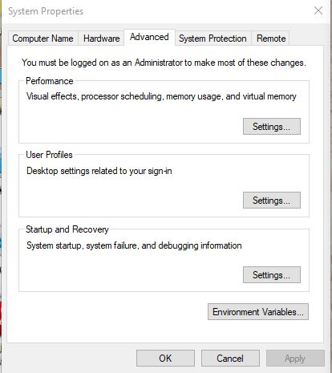

**Screen1: properties wizard**

Now check the latest and correct version for JDK installation to the instructions of latest wizard.

**Step1.2:** path setting for java.

* + Go to advanced settings and then click on environment variables
  + create a class path and copy the path of the java folder where it is located in program files.

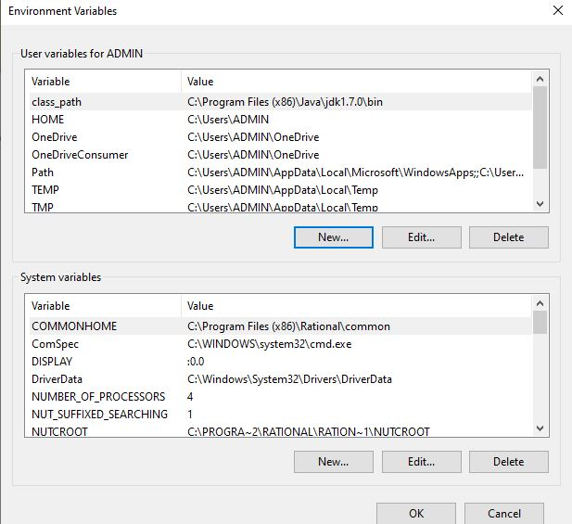

**Screen1.2: path setting for java**

Select the class _ path which is suitable to the project then click new button and click ok button.

**Installation and setup of Apache Tomcat:**

**Step2:** Go to <http://tomcat.apache.org/index.html> and click on download latest versions.

Run the exe file and click on next and follow the wizard instructions.

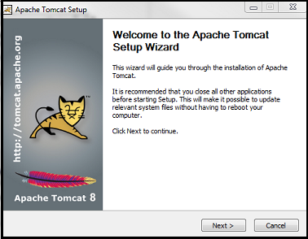

**Screen2: Welcome Page of Tomcat**

Click on install with port number 8090 with username and password as **aits** and **aits.** Mention the connection port as 8090 and then click on next and finally click on finish.

**Step2.1:** Enter the port number correctly and click to the next button.

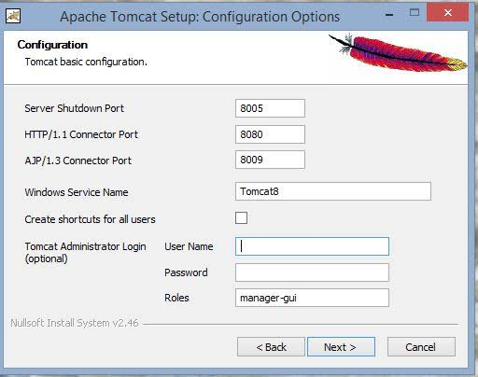

**Screen2.1: Tomcat Configuration Options Page**

**Description:** Click on I agree button in. license agreement in order to accept the terms and condition.

**Step2.2:** Agree the Tomcat license agreement.

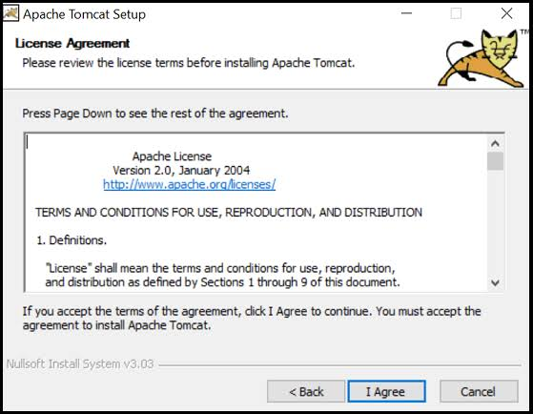

**Description:** check the license and agree the terms and conditions for go to the next level.

**Step3: Installation and setup of SQL:**

Go to<http://dev.mywql.com/downloads/> . and click on install button.

After completion of installation, click on exe file and then click on next.

Run the MySQL setup and click on next and follow the instruction in wizard.

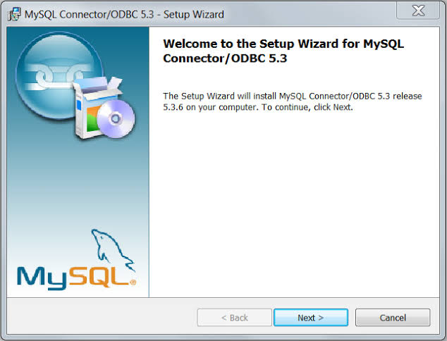

**Screen3: Welcome wizard of MySQL**

**Step3.1:** Conform the type as typical and then click on next and follow the instructions.

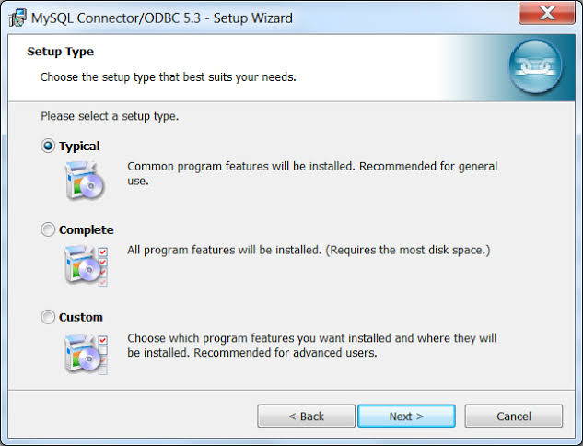

**Screen3: SQL setup Wizard**

**Description:** Now confirm the password as root in system settings field and then click on finish.

**Step3.1:** Enter the password correctly and click to the next button.

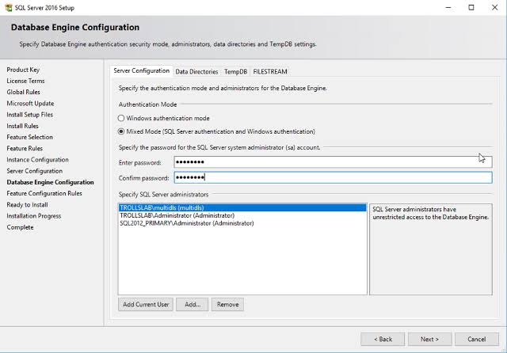

**Screen: Database Configuration Engine**

**Description:** Submit the data successfully in the database engine configuration.

**5.2 Sample Screens & reports**

**Step1:** Enter the home page.

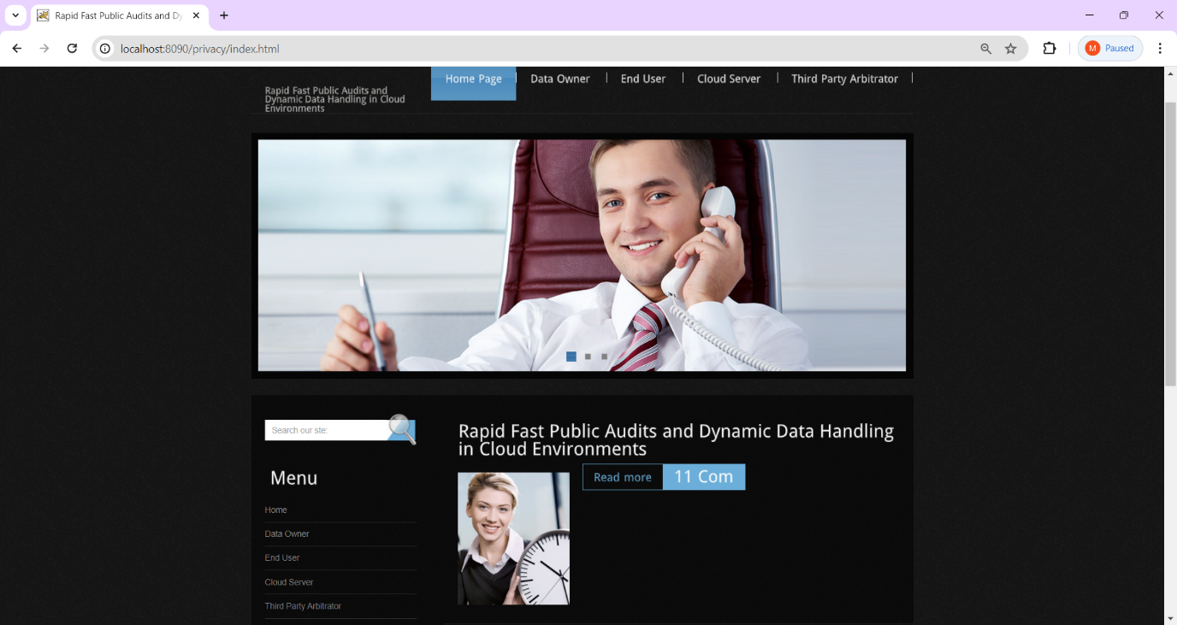

**Screen: 5.2.1: Home page**

**Description:** Observe the home page and the elements in this view.

**Step2:** Click the cloud server and login.

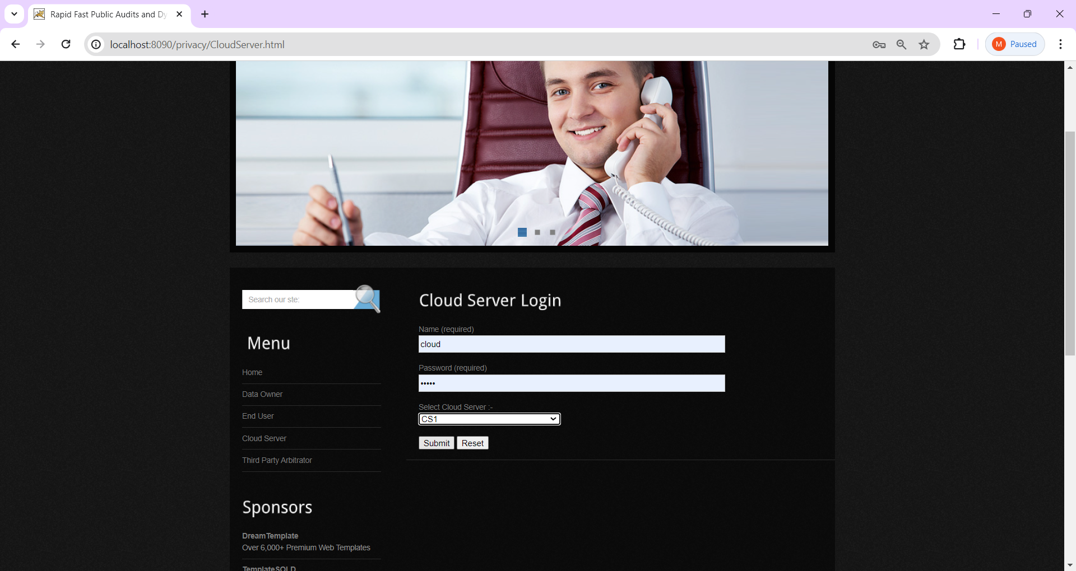

**Fig: 5.2.2. View cloud login page.**

**Description:** Initially register and fill the requirements successfully and login again into the cloud server with the name and password as ‘cloud’ and submit.

**Step3:** View cloud server1 panel.

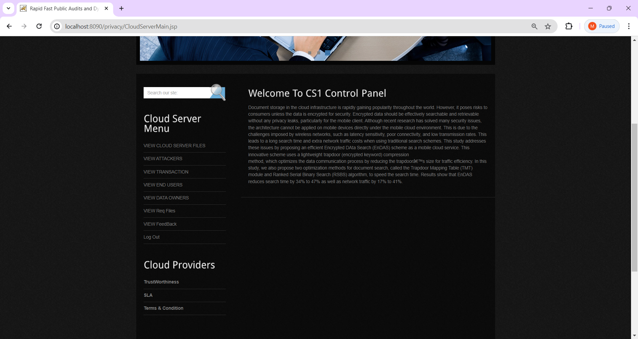

**Fig:5.2.3. Observe welcome page.**

**Description:** Let us see the cloud server1 panel and observe the menu in it.

**Step4:** Click the Third party auditor and login.

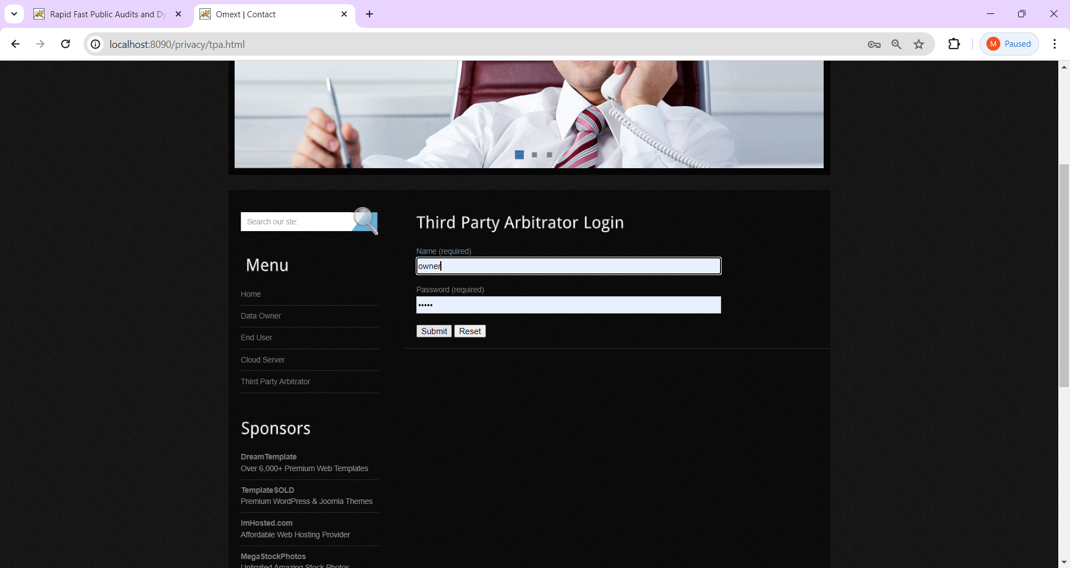

**Fig: 5.2.3. View TPA login.**

**Description:** fill the data and click the submit button.

**Step5:** Observe the welcome Third party auditor page.

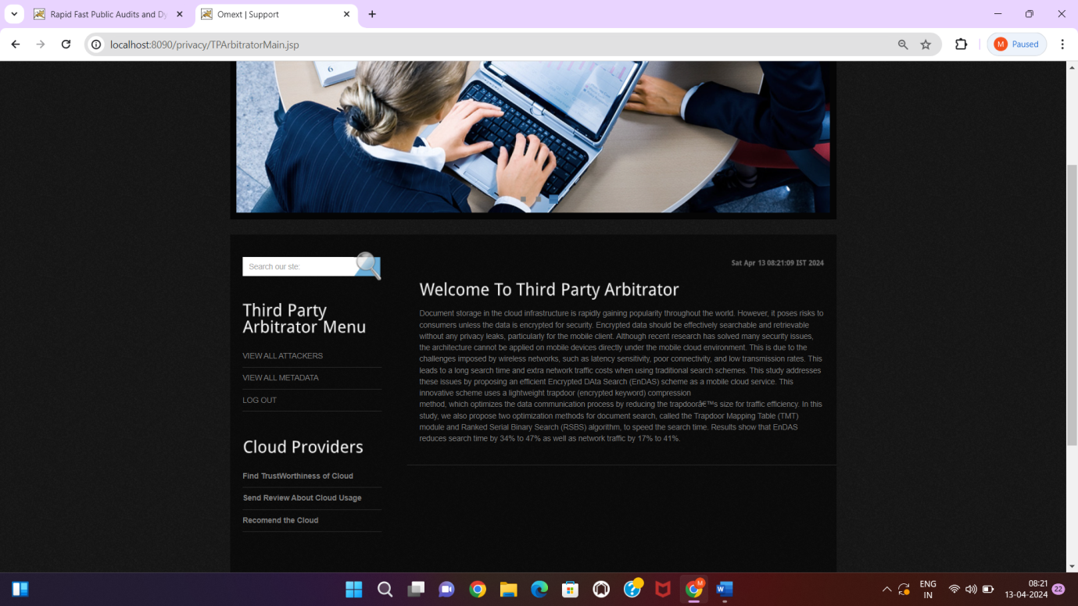

**Fig: 5.2.4. Observe welcome page.**

**Description:** We can see the menu of Third party auditor.

**Step6:** Click to the data owner page then register successfully.

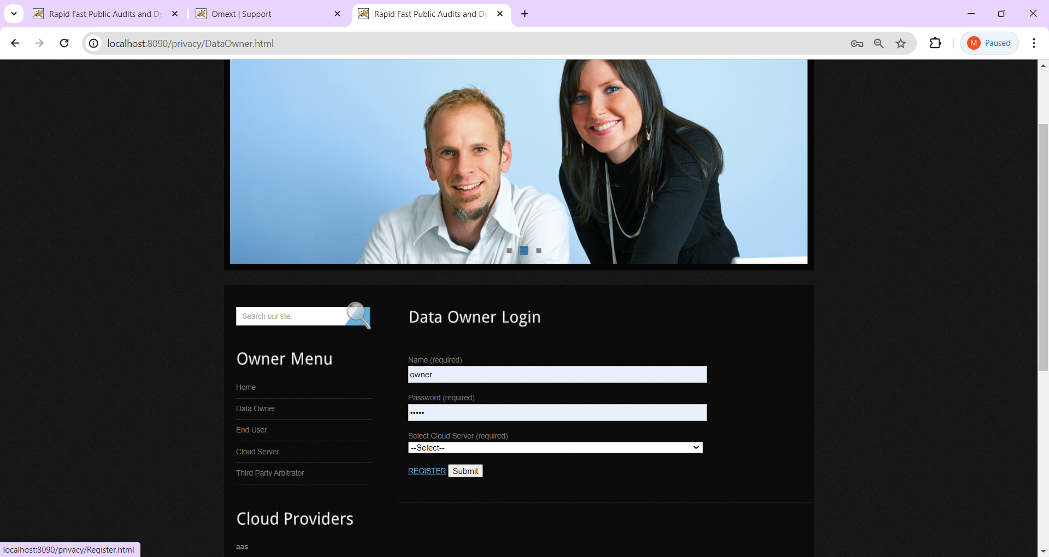

**Fig: 5.2.5. Click the register.**

**Description:** Observe the data owner and login after registration.

**Step7:** Fill the details in the registration and submit successfully.

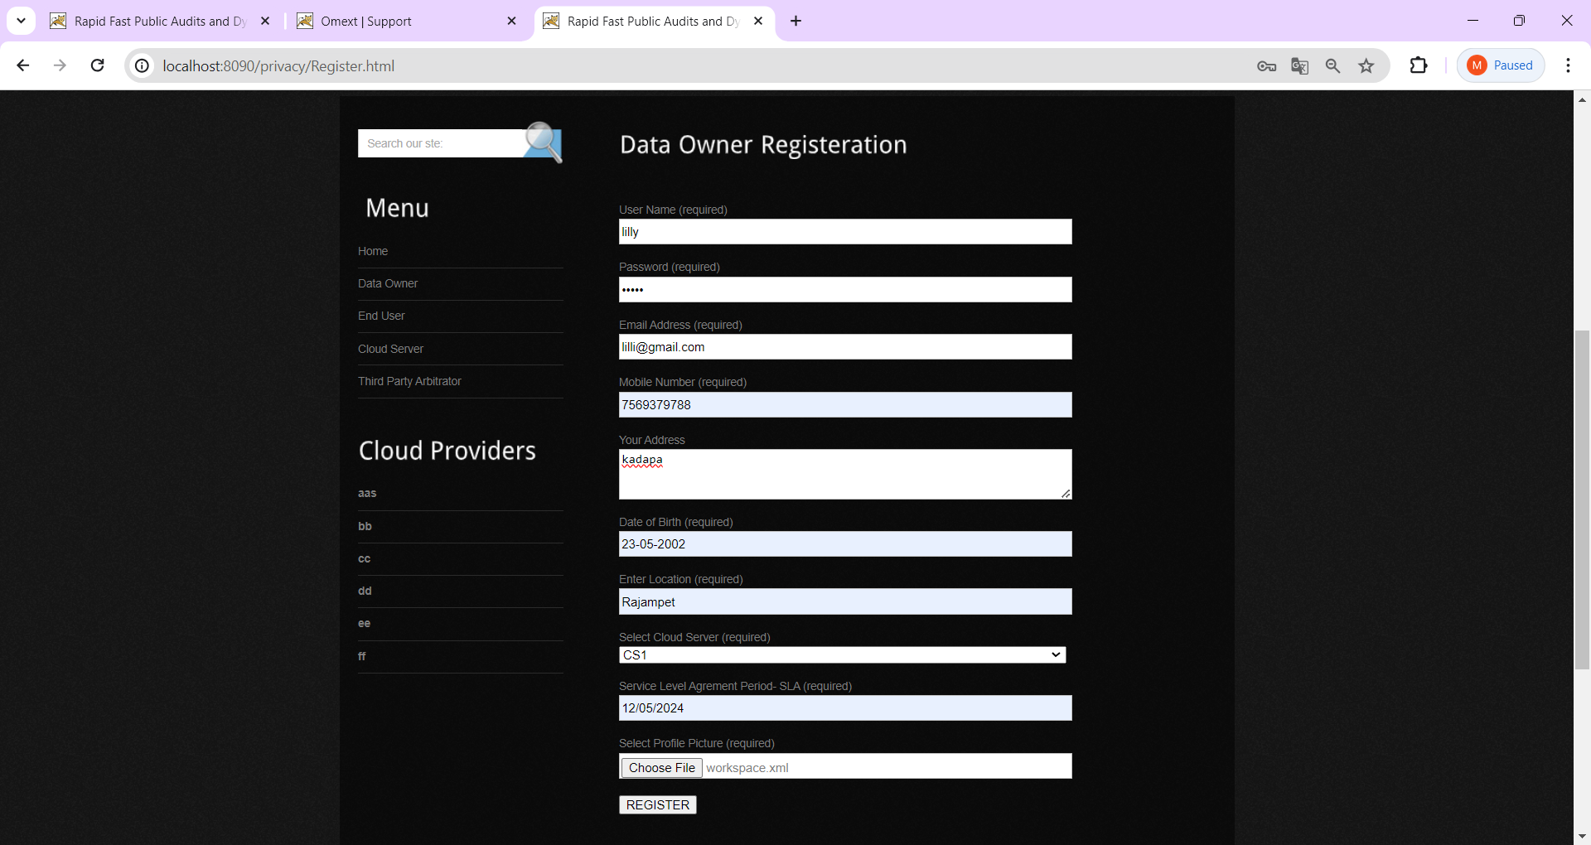

**Fig: 5.2.6. Fill the registration.**

**Description:** Fill the information correctly and submit.

**Step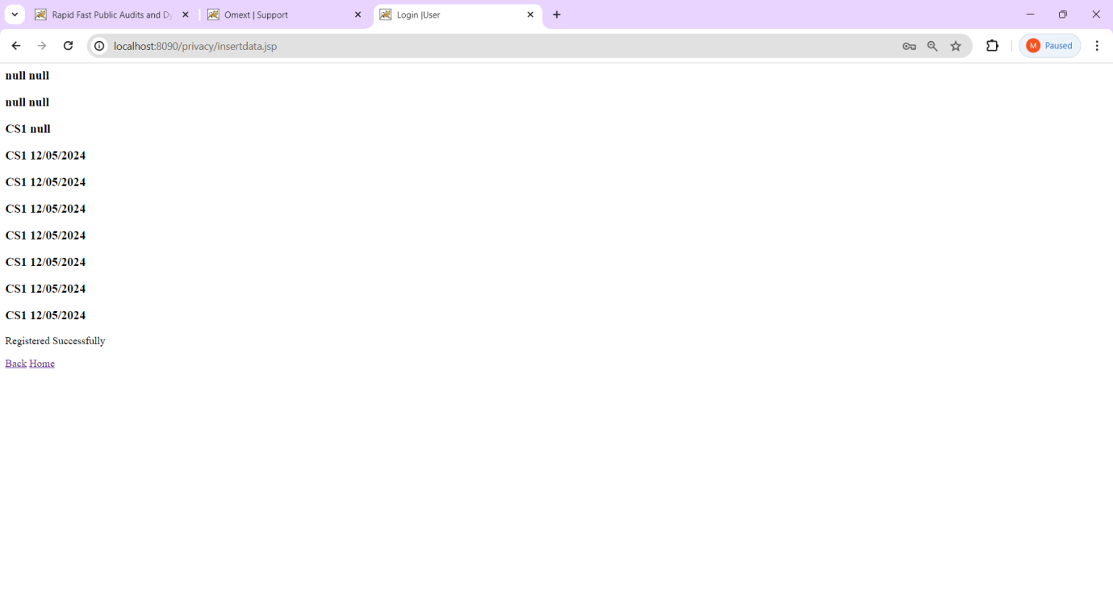8:** View registered successfully.

**Fig: 5.2.7. Registered successfully.**

**Description:** Observe registration and click home.

**Step9:** See the Data owner wecome page.

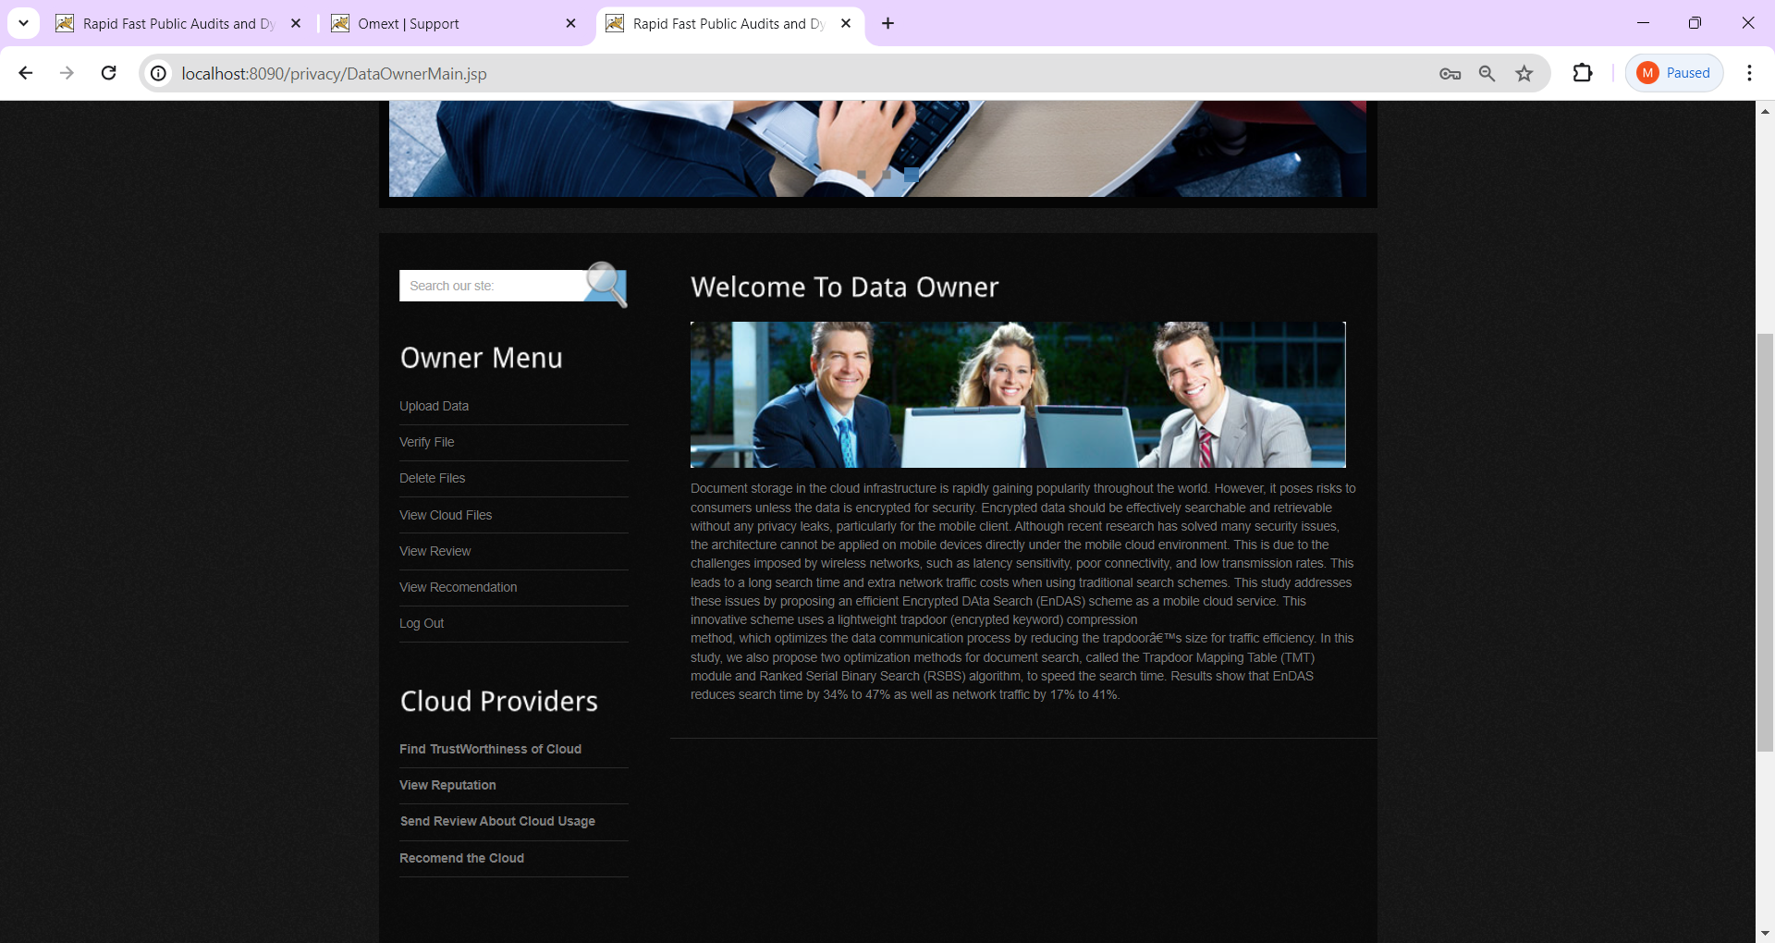

**Fig: 5.2.8. Observe welcome page.**

**Description:** Place the welcome page for ready to see the menu.

**Step10:** Enter the user login and register.

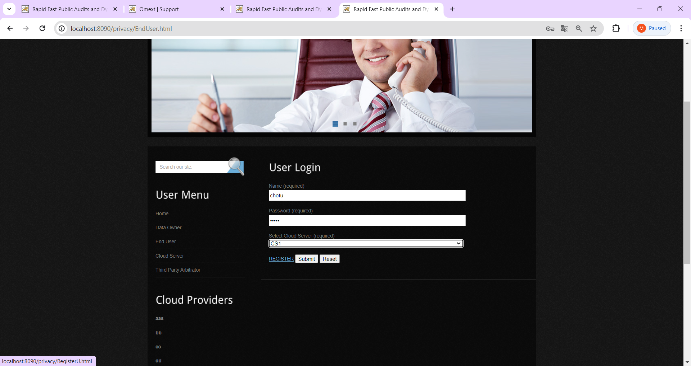

**Fig:5.2.9. Login and submit.**

**Description:** Register the successfully and submit.

**Step11:** Observe User Registration.

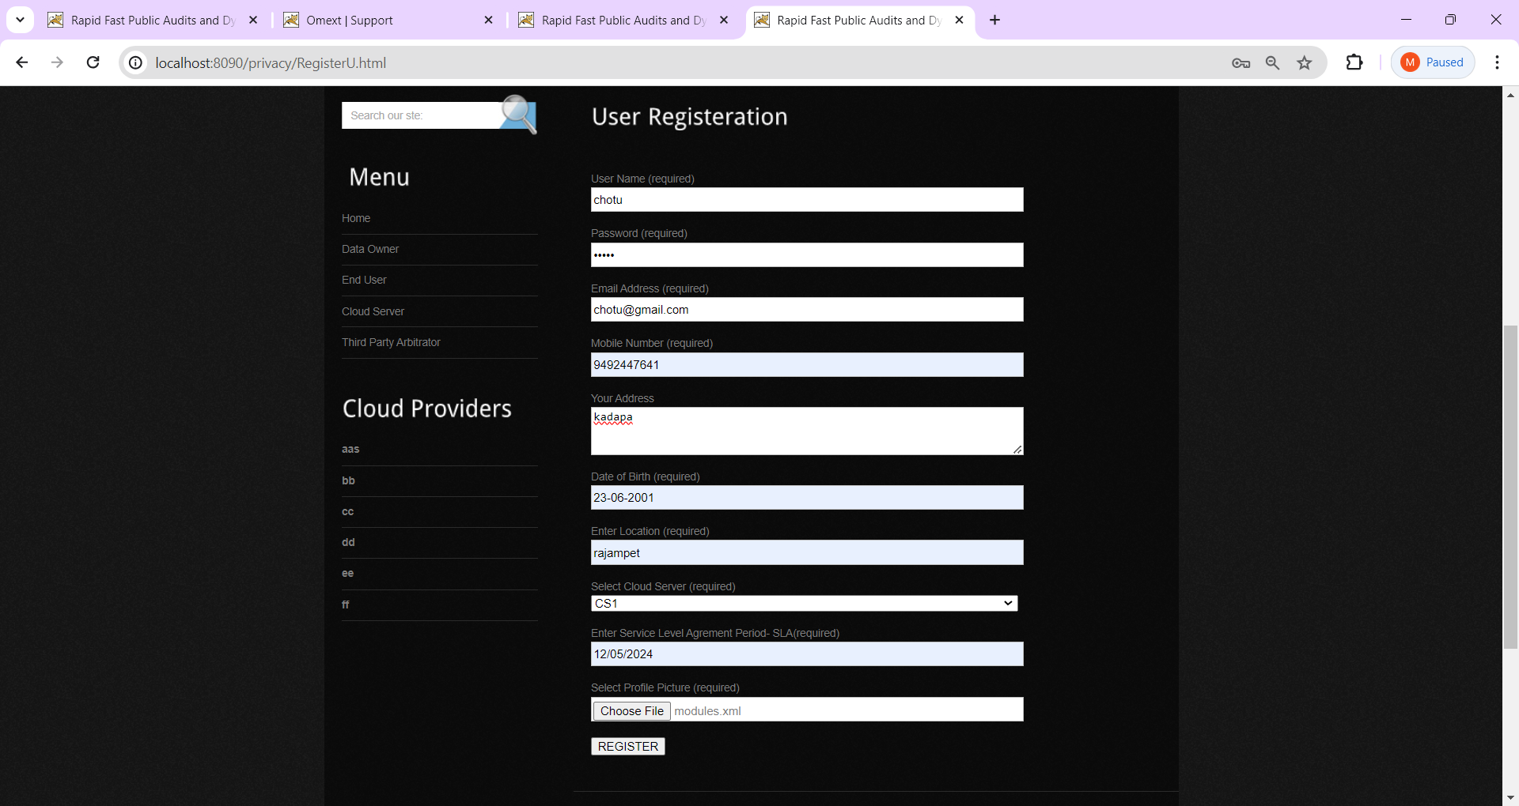

**Fig: 5.2.10. Fill the user registration.**

**Description:** Enter the details carefully and registered.

**Step12:** Observe this for sucessfully registered.

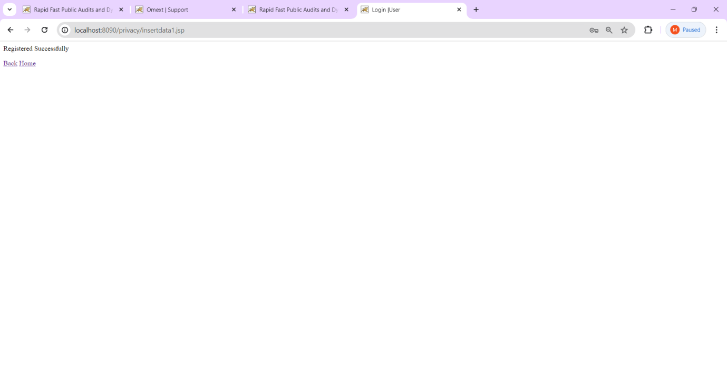

**Fig: 5.2.11. View registered successfully.**

**Description:** Click the home page.

**Step13:** let us see the user welcome page.

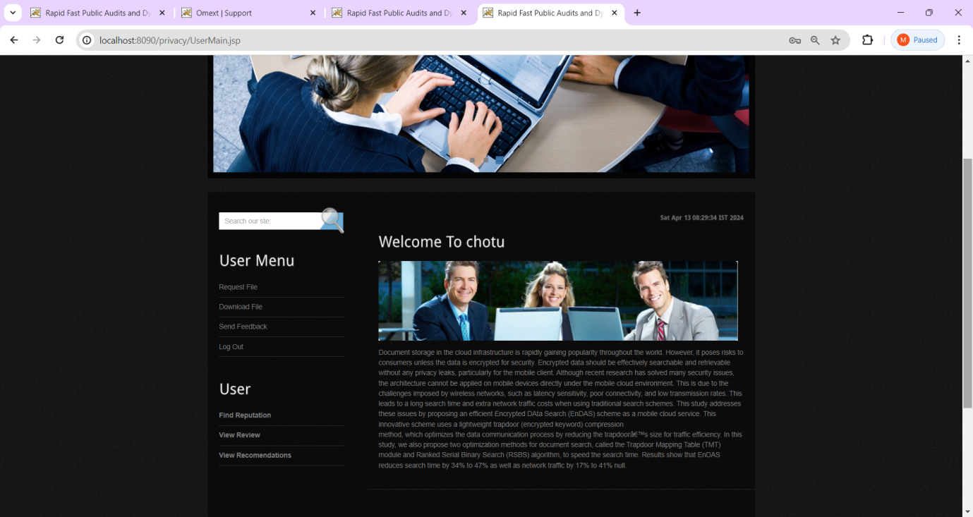

**Fig:5.2.12. Observe the user welcome page.**

**Description:** We can see the user menu in this.

**Step14:** Observe the request page.

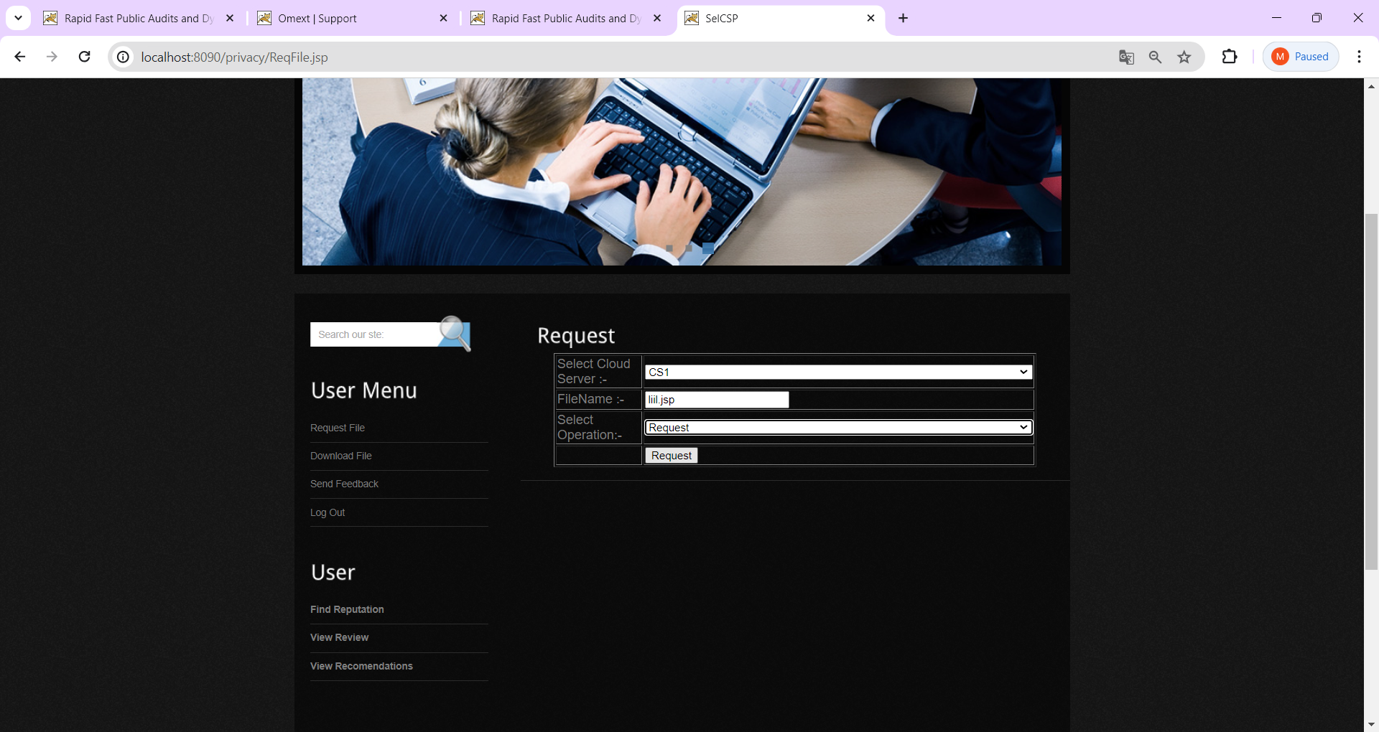

**Fig:5.2.13. View request page.**

**Description:** I send a request to the cloud server for get the information.

**Step15:** Successfully requested.

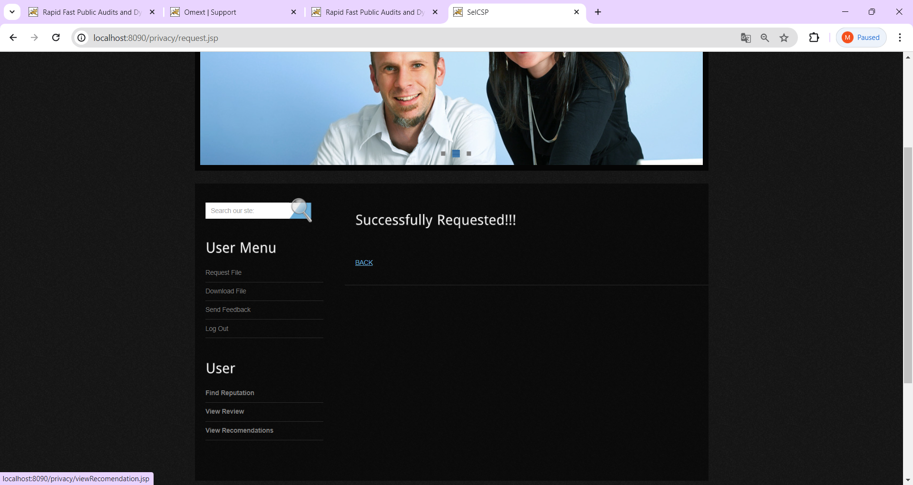

**Fig:5.2.14. Registered successfully.**

**Description:** In this we can see the user menu.

**Step16:** We can see requested data.

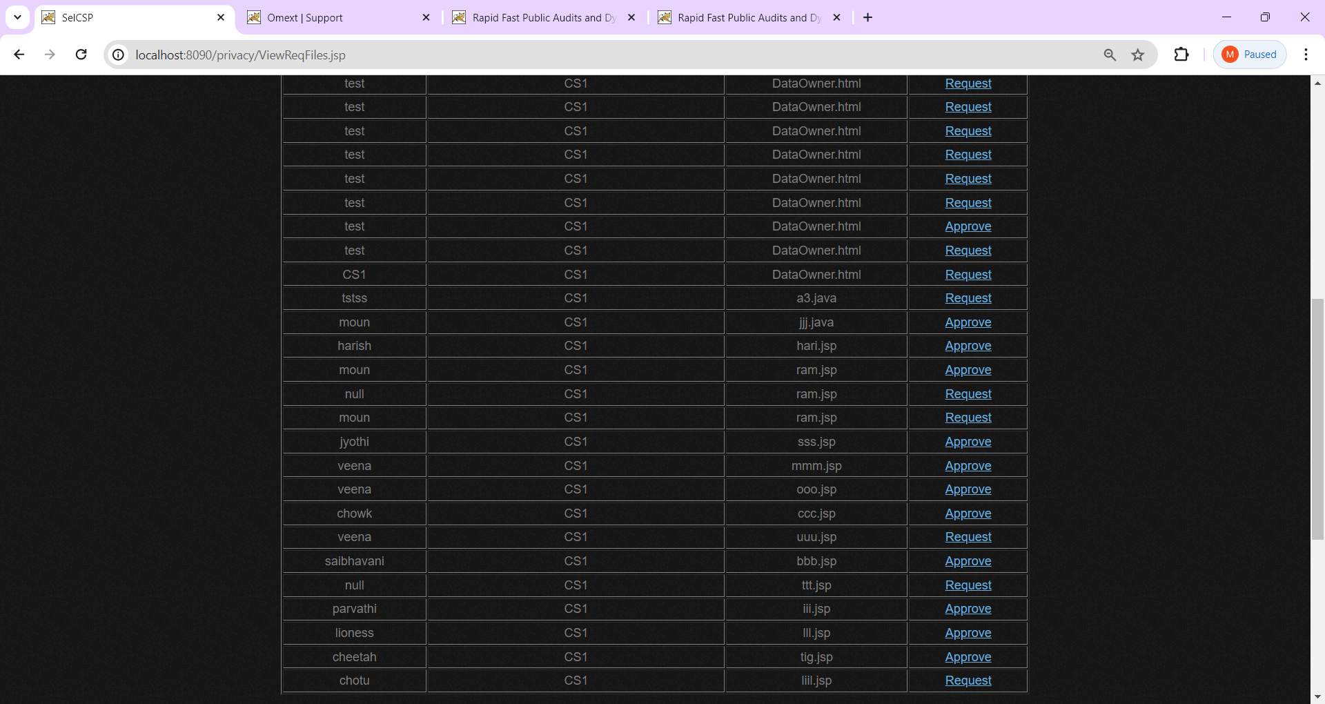

**Fig:5.2.15. Observe the requested data.**

**Description:** Here we can see how many candidates are requested.

**Step17:** Give response from the cloud server.

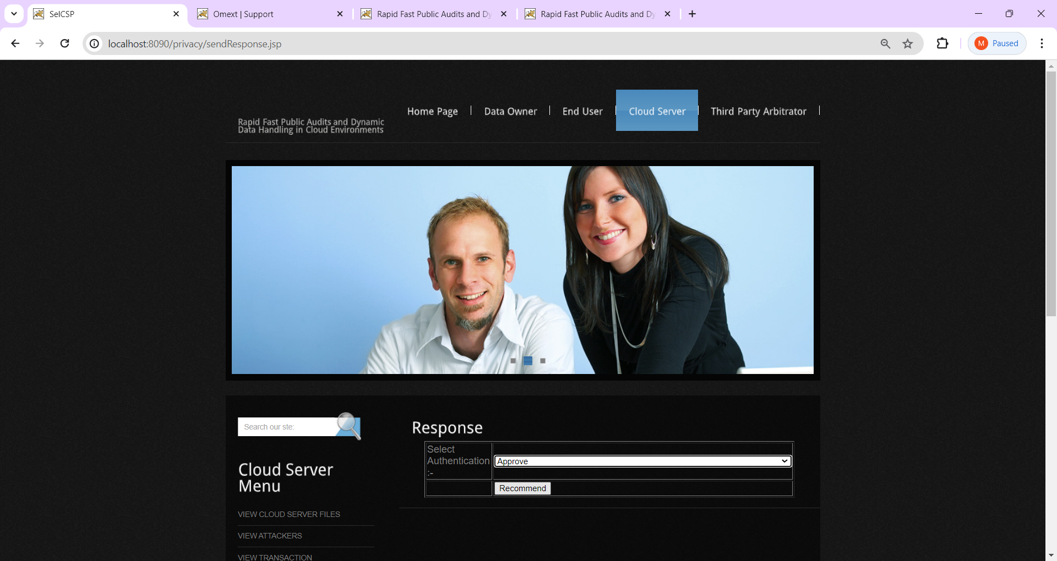

**Fig: 5.2.16. View response.**

**Description:** Here approve and recommended.

**Step18:** Sent response from the cloud server.

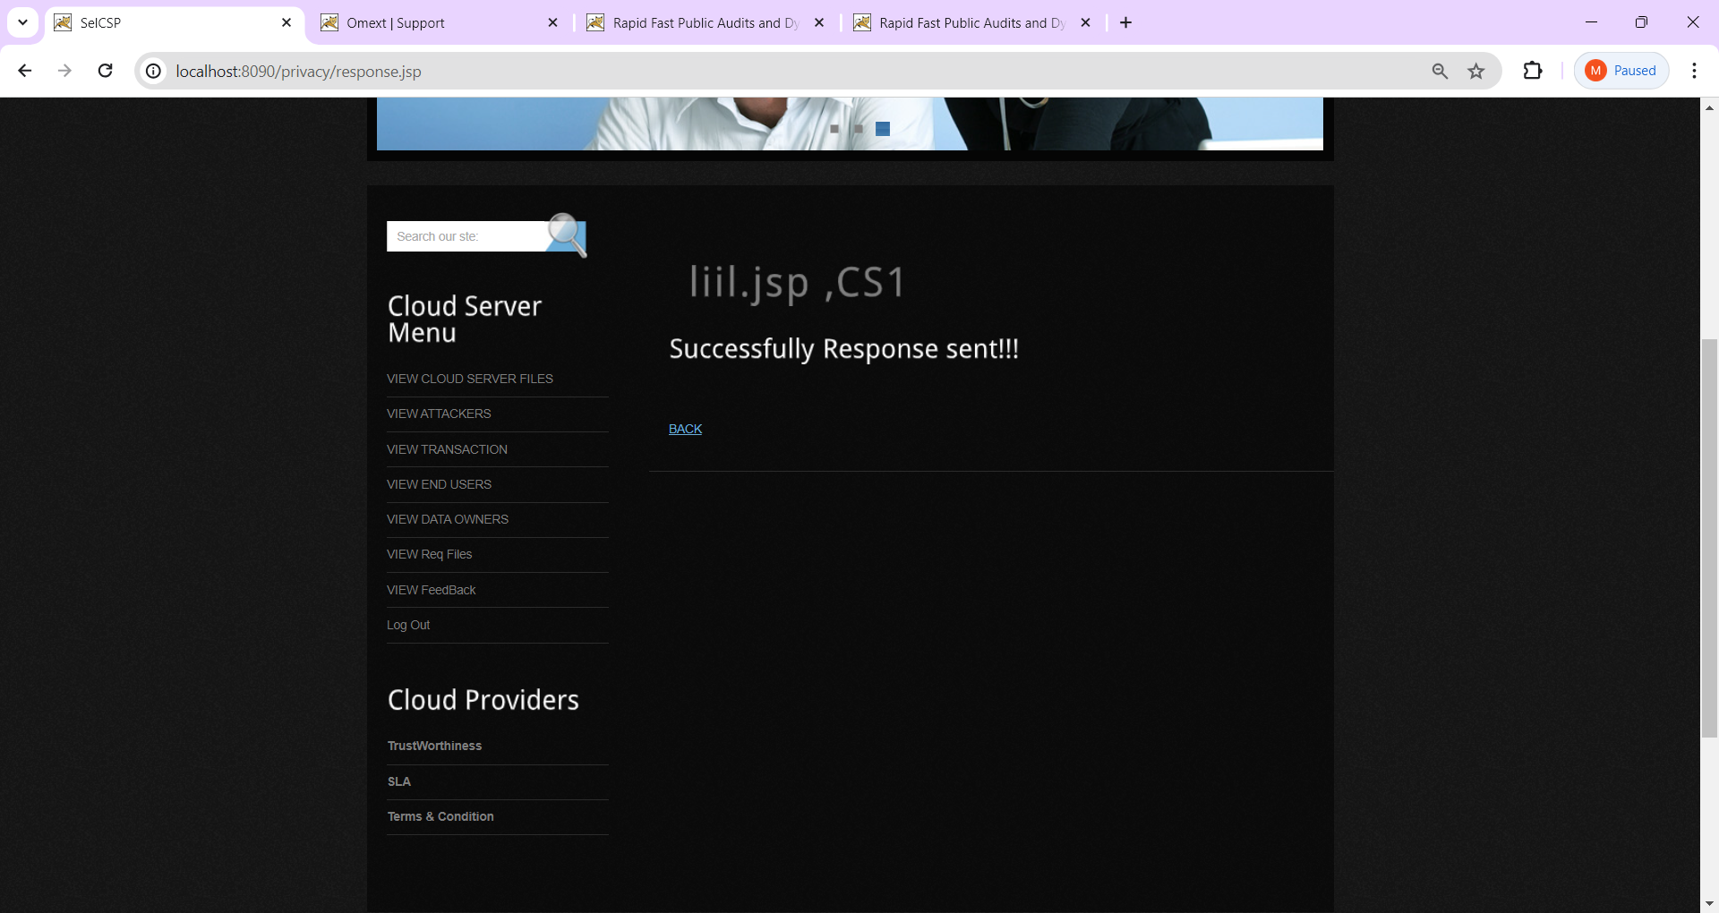

**Fig: 5.2.17. Response successfully.**

**Description:** Observe the cloud server menu.

**Step19:** Encrypt the data here.

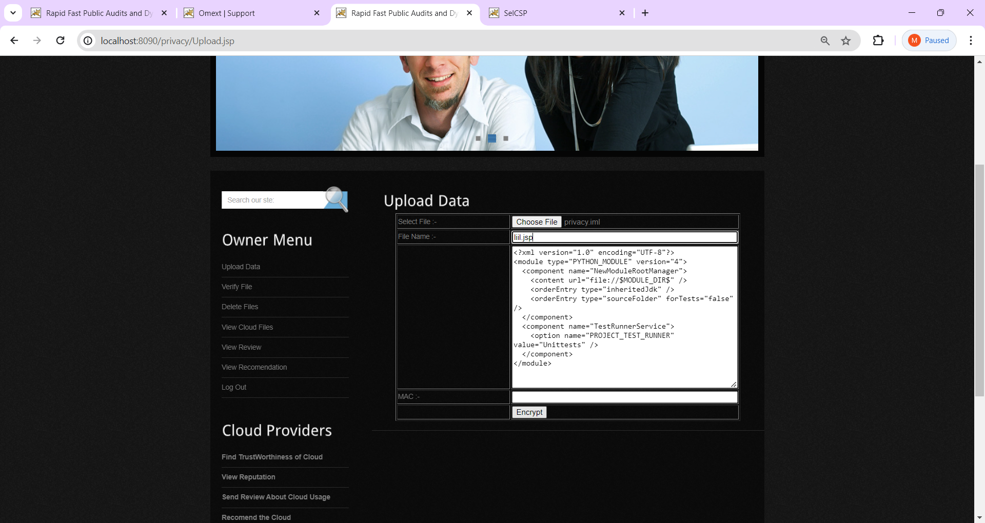

**Fig: 5.2.17. Encrypted data.**

**Description:** We can see the attributes in this.

**Step20:** Changed the data into secret language.

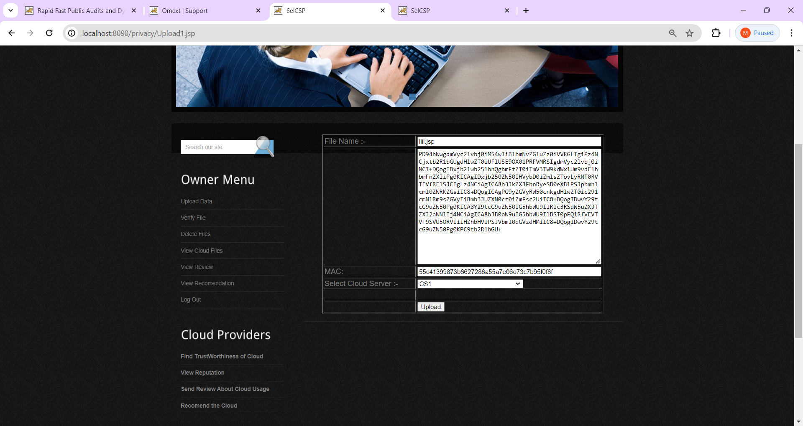

**Fig:5.2.19. Select the cloud in data.**

**Description:** The data should be uploaded.

**Step21:** Data uploaded successfully.

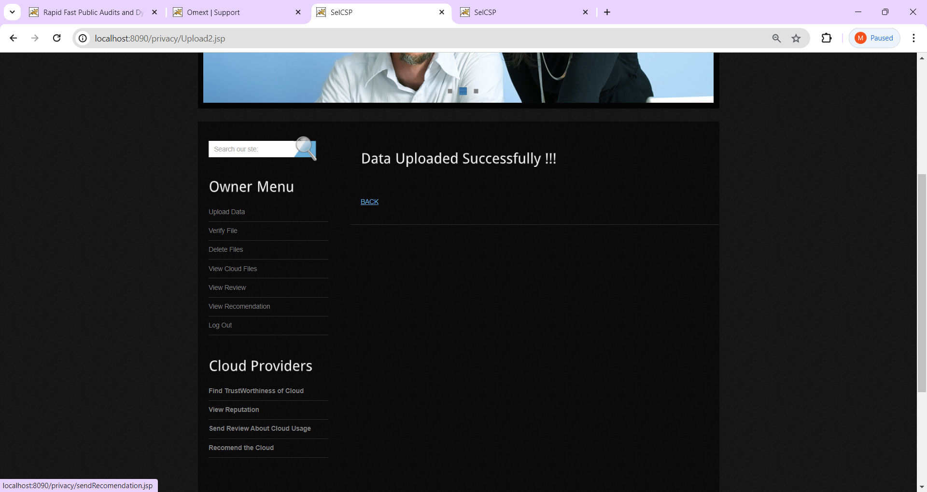

**Fig: 5.2.20. Uploaded data successfully.**

**Description:** Here the should be uploaded then click back button.

**Step22:** Enter the file name.

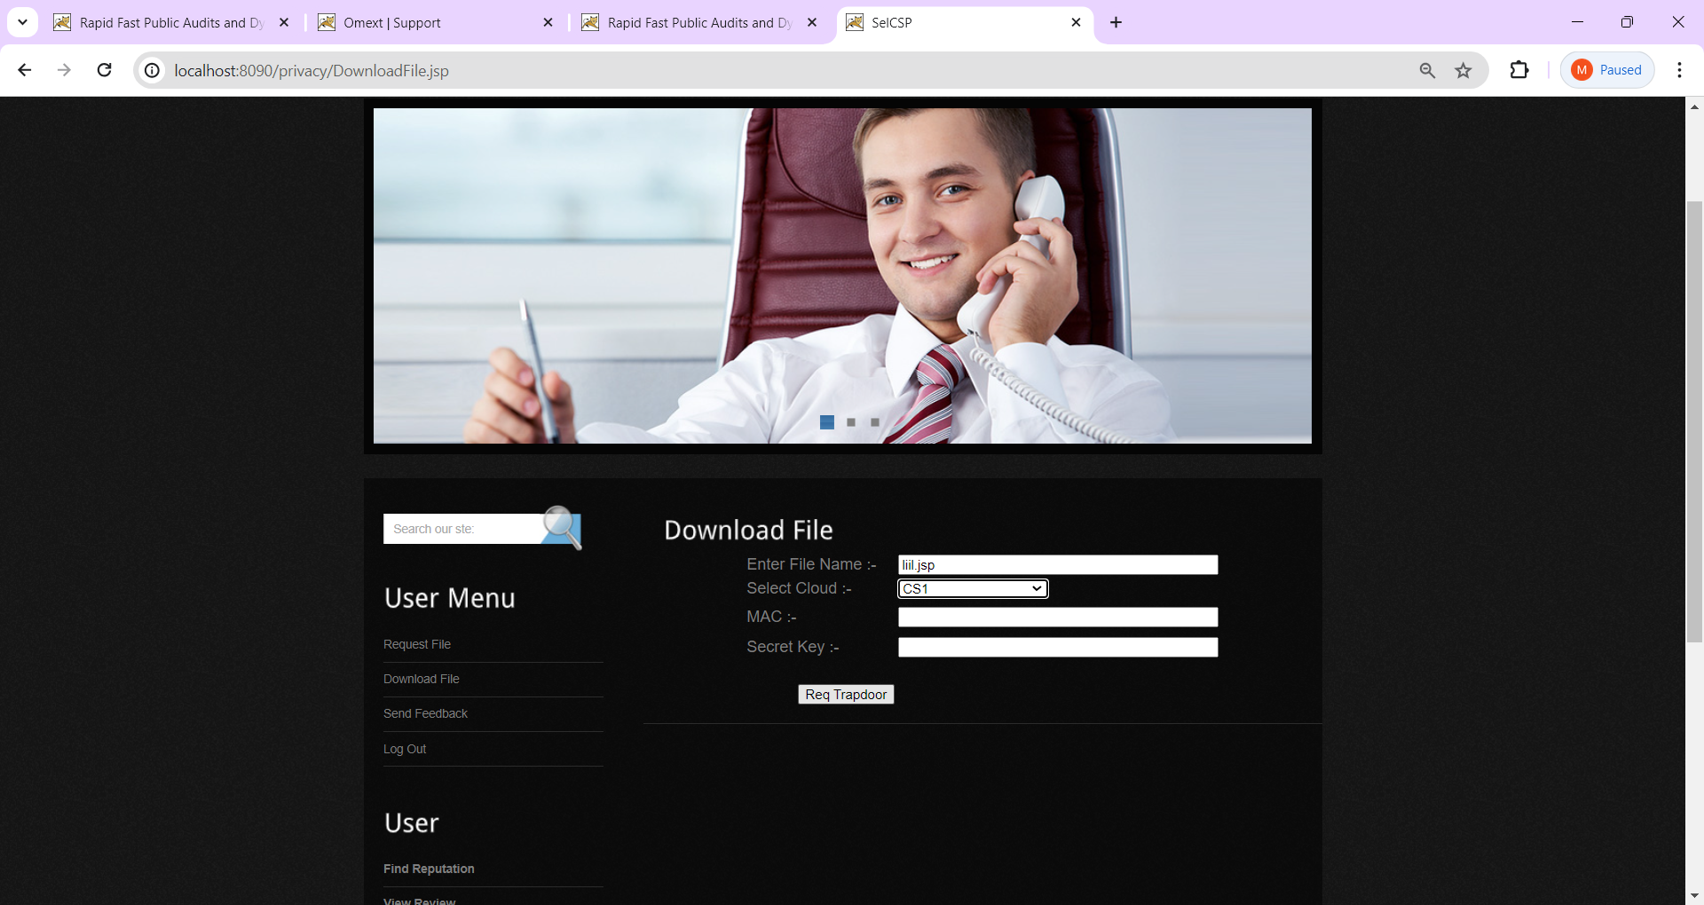

**Fig:5.2.21. Add the file name and cloud.**

**Description:** Enter the file name and clod to download data.

**Step23:** Click the download.

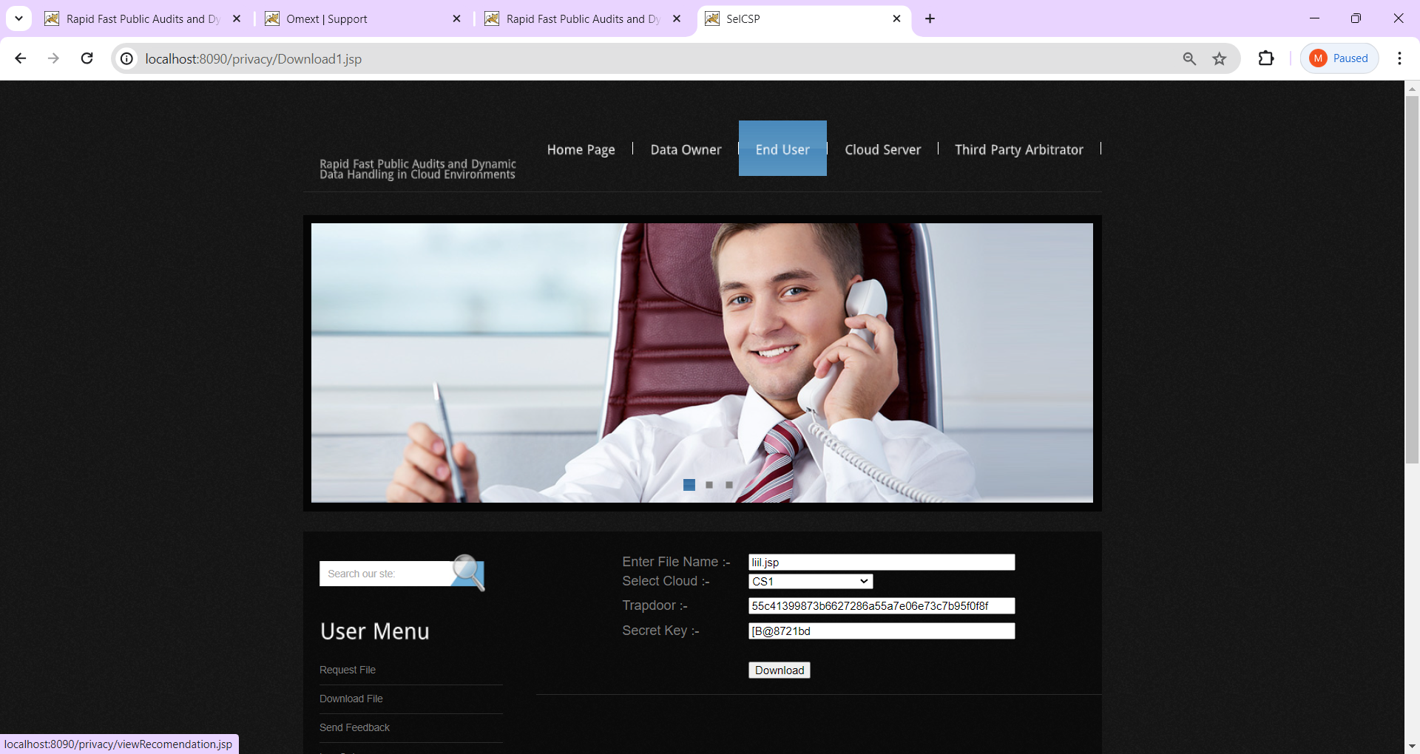

**Fig: 5.2.22. Downloaded here.**

**Description:** Select the cloud and download.

**Step24:** Write a feedback and submit.

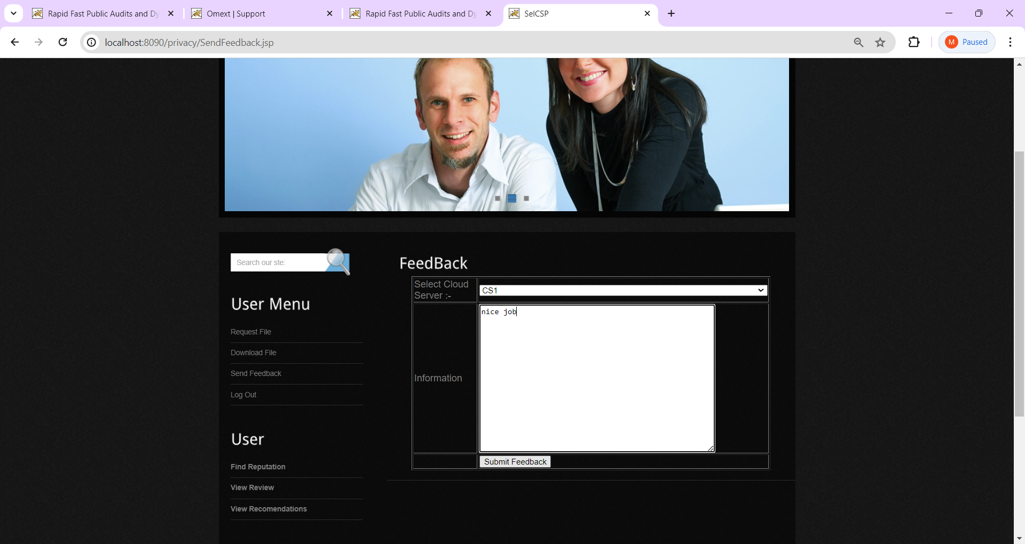

**Fig:5.2.23. Enter feedback and select cloud.**

**Description:** Select cloud and submit.

**Step25:** View feedback successfully.

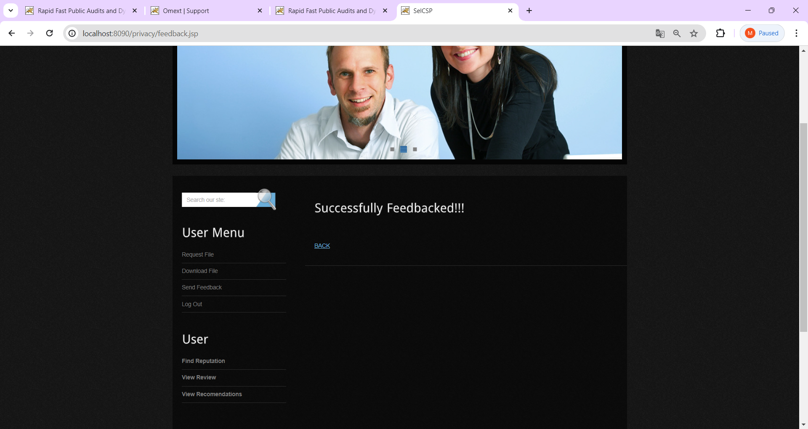

**Fig:5.2.24: Observe feedback successfully.**

**Description:** We can see feedback successfully and click back button.

**Step26:** View feedback details.

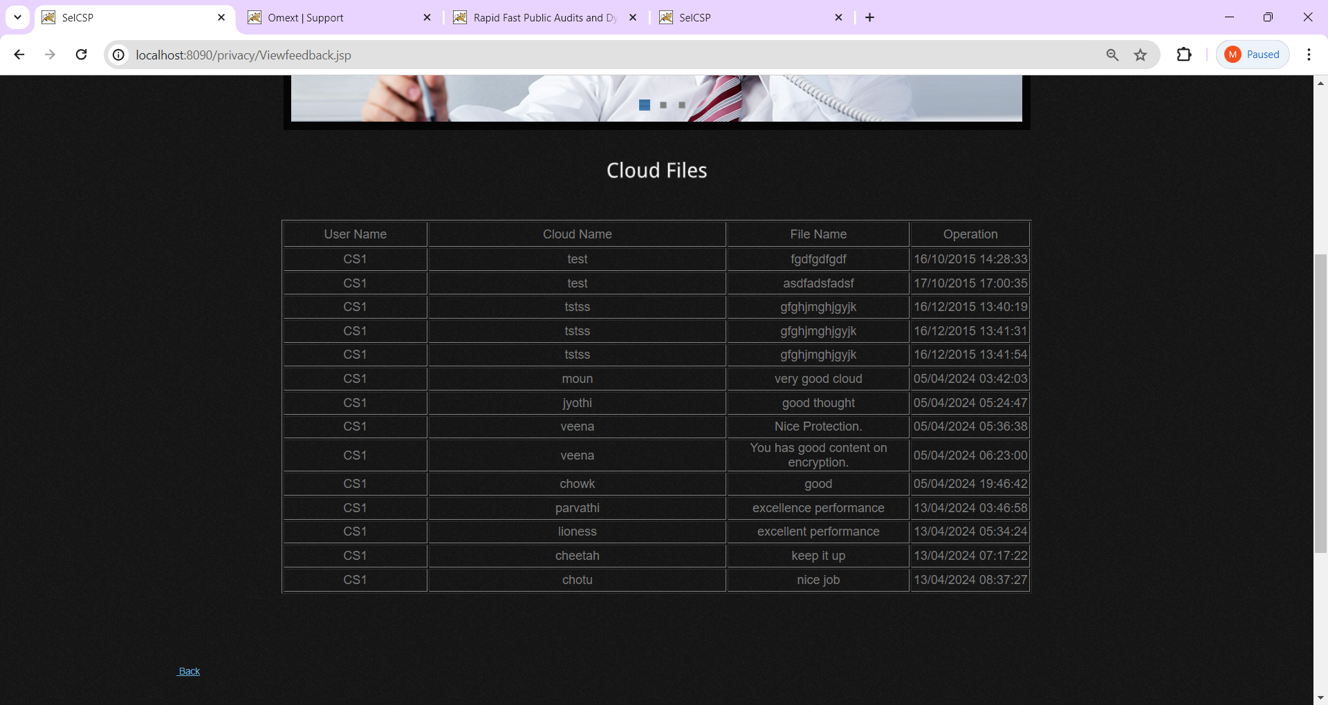

**Fig: 5.2.25. Observe details here.**

**Description:** See the data and click back.

**Step27:** View attackers.

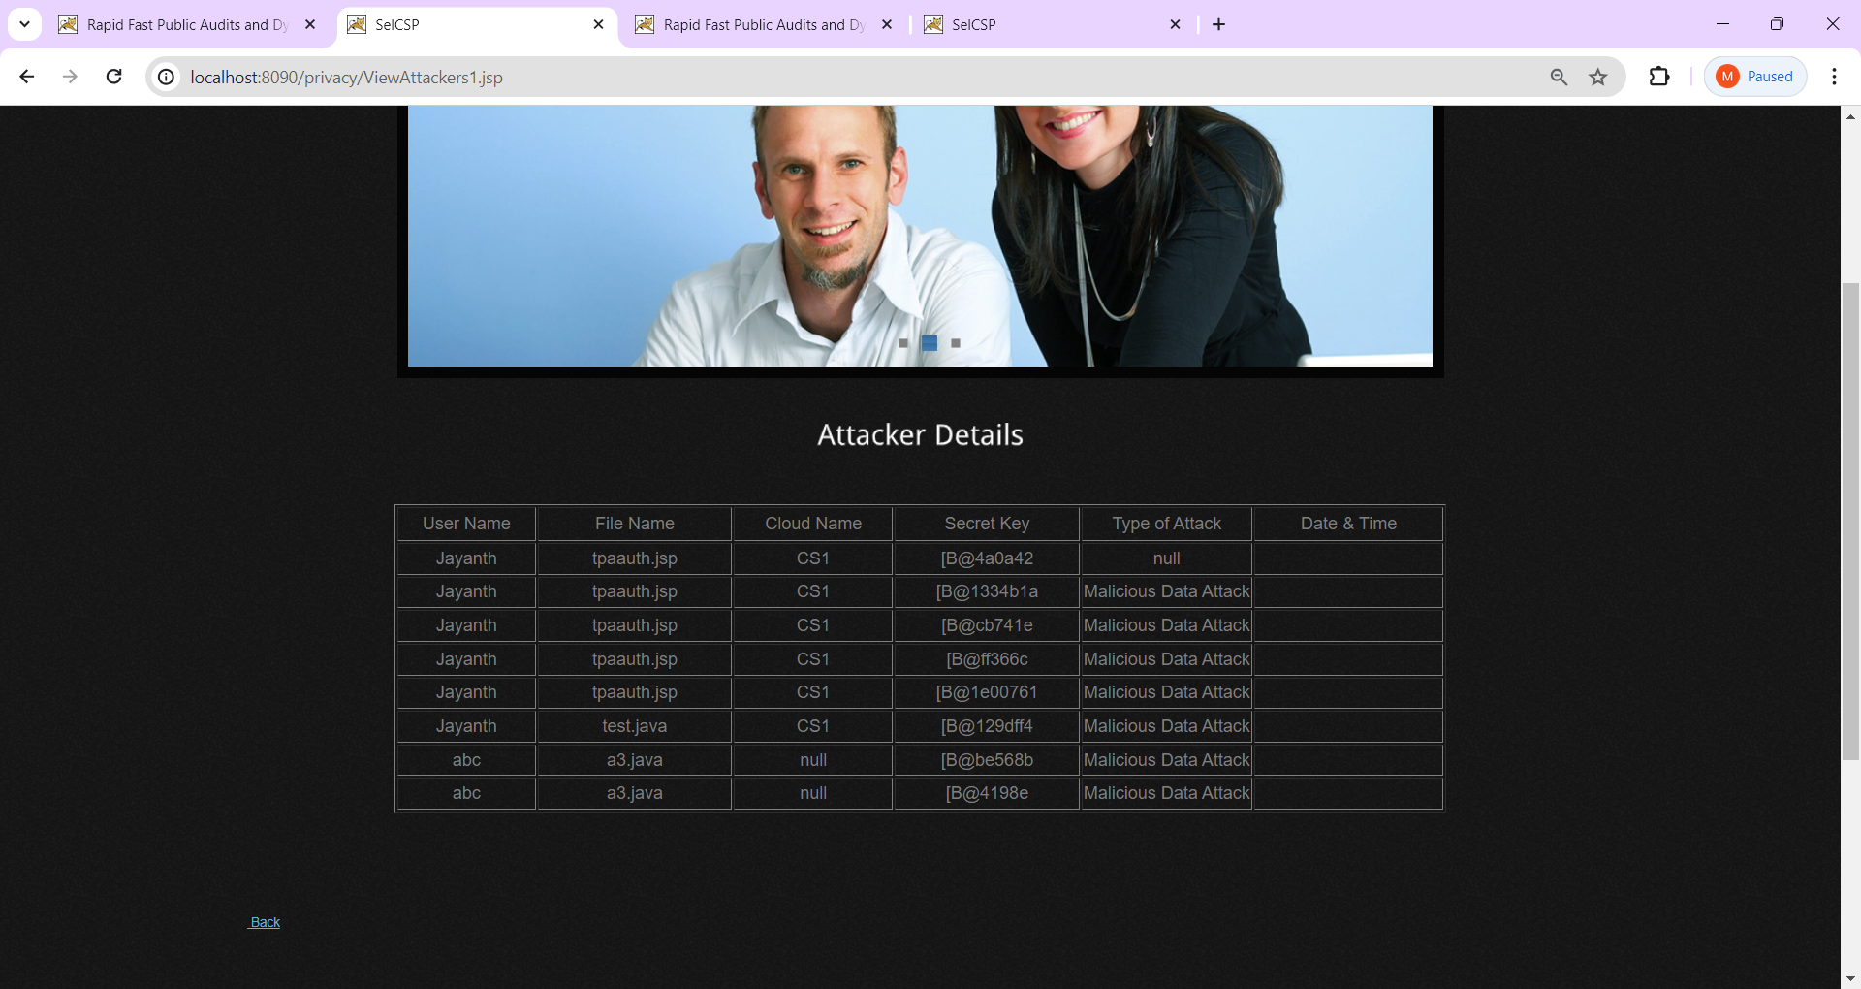

**Fig:5.2.26. Observe the attackers details.**

**Description:** See the details and click back.

**Step28:** View content secured.

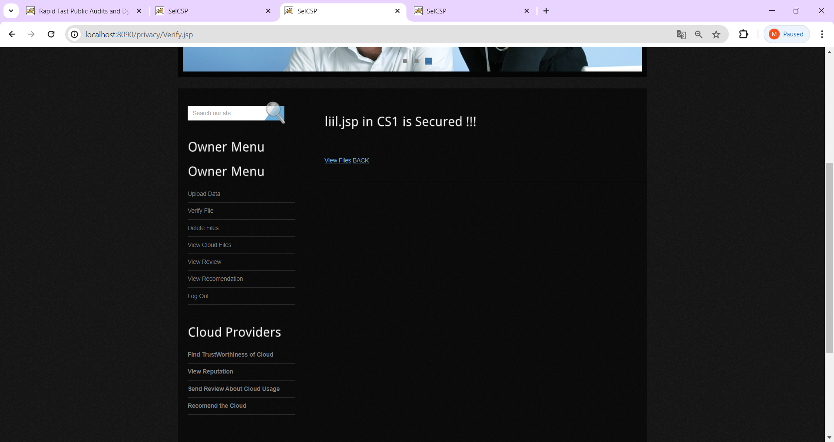

**Fig: 5.2.27. Data secured.**

**Description:** Data secured and Click the back button.

**Step29:**  Enter cloud and file name.

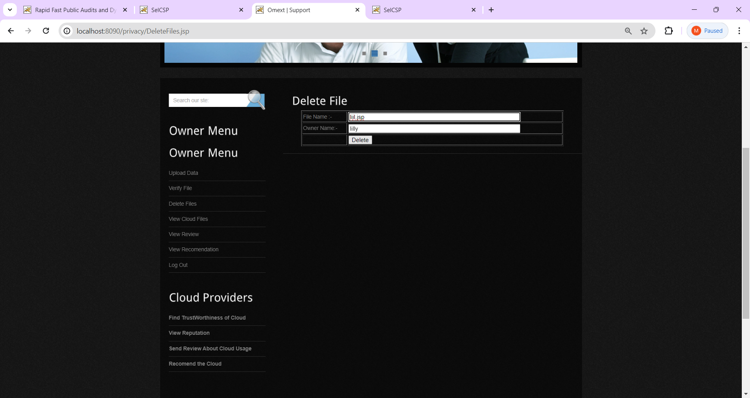

**Fig:5.2.28. Click deleted button.**

**Description:** Select the file and delete.

**Step30:** Data deleted successfully.

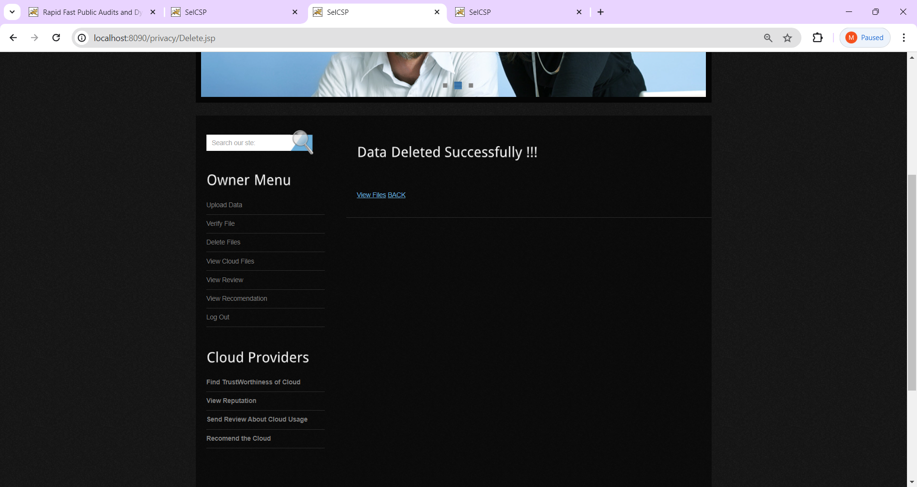

**Fig:5.2.29. Data deleted and click back.**

**Description:** Observe data deleted and view deleted files.

**Step31:** Verify file.

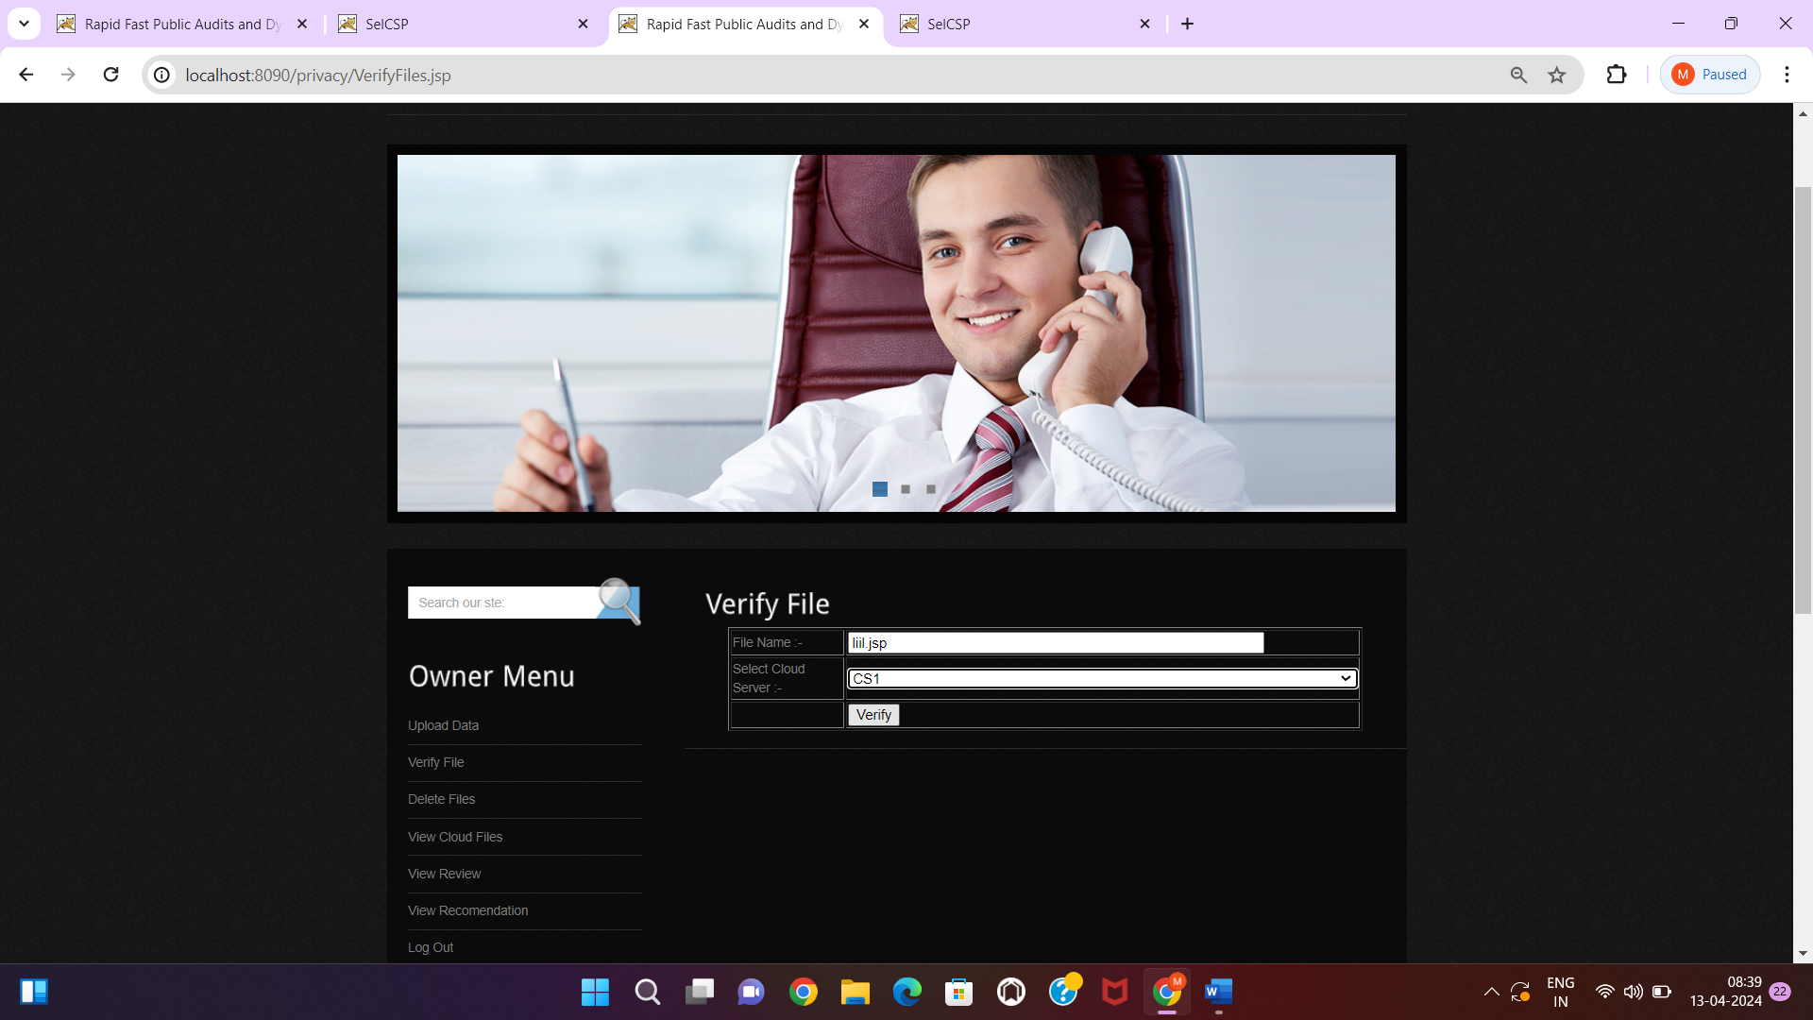

**Fig: 5.2.30. Enter file and cloud then verify.**

**Description:** Select the cloud and verify.

**Step32:** View attacker.

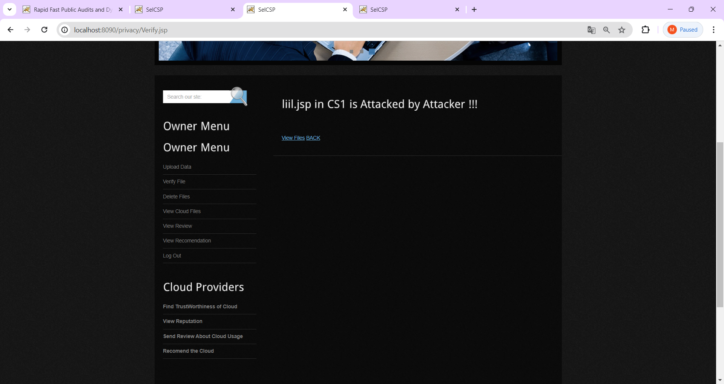

**Fig: 5.2.31. Observe clearly attackers.**

**Description:** Let us see the attacked by the attacker.